**Chapter 4**

**IMPLEMENTATION**

**Admin/HOD module:**

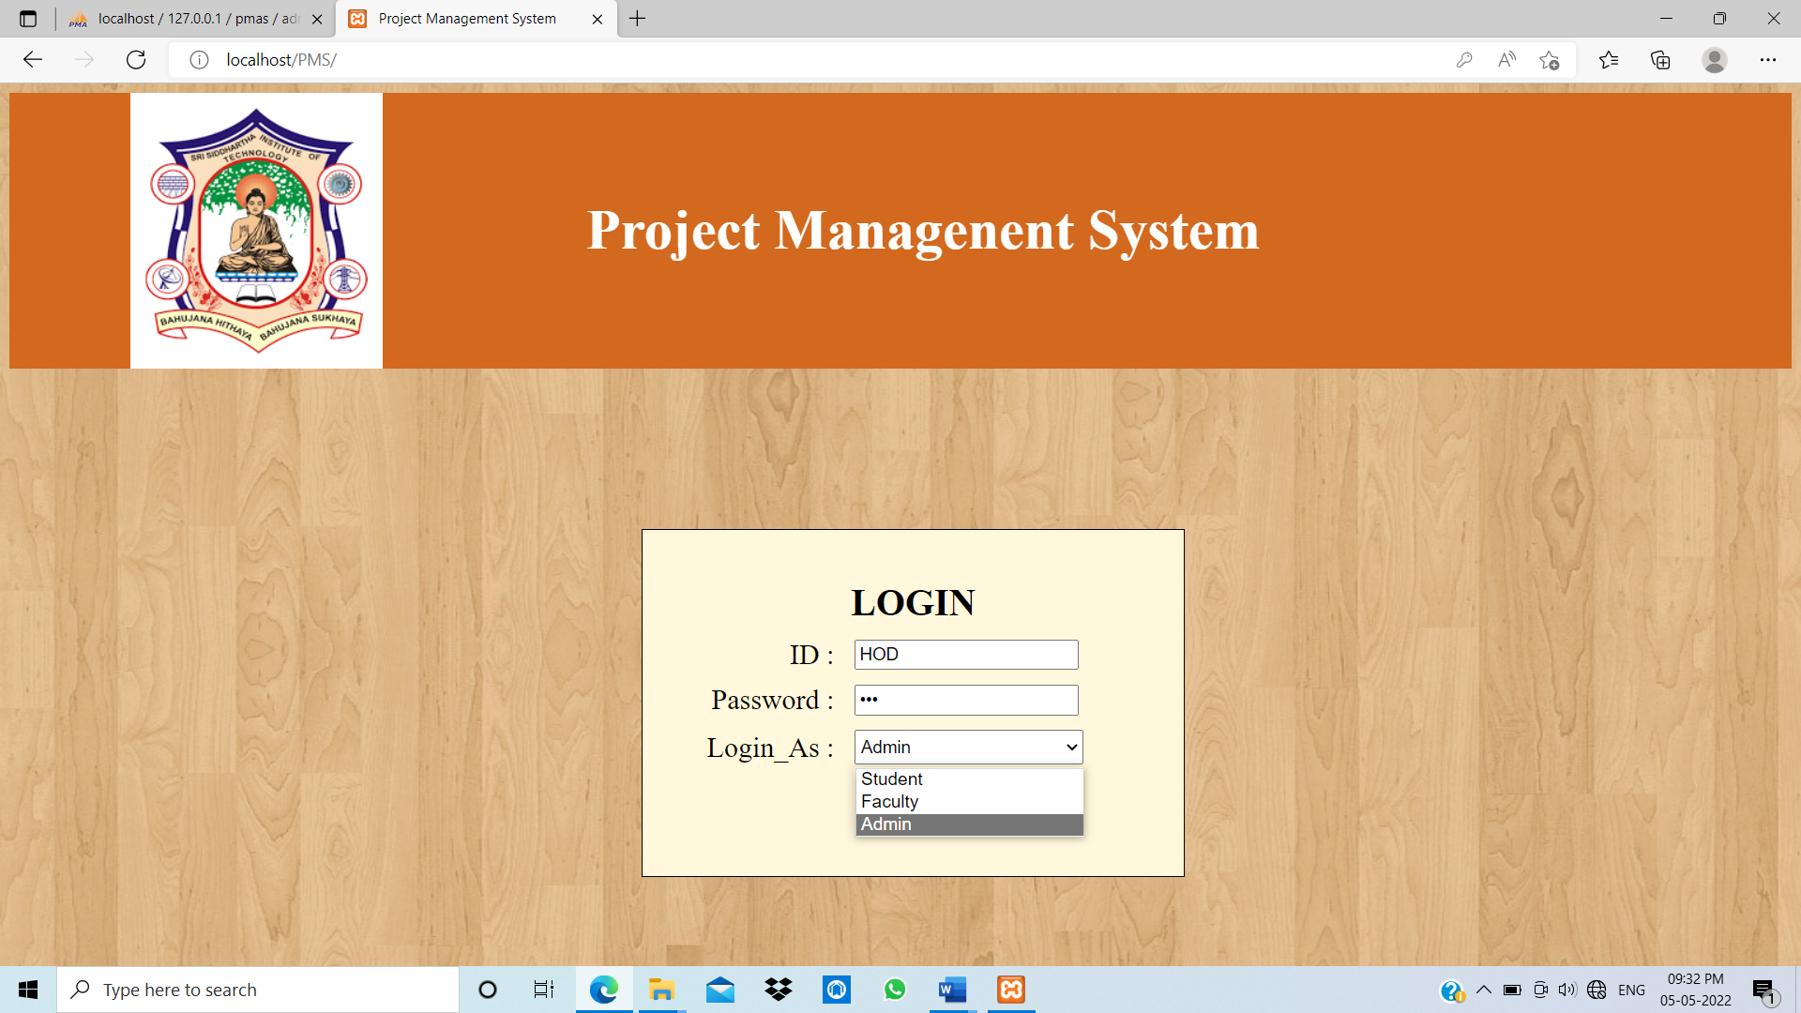

Fig 1: Login page

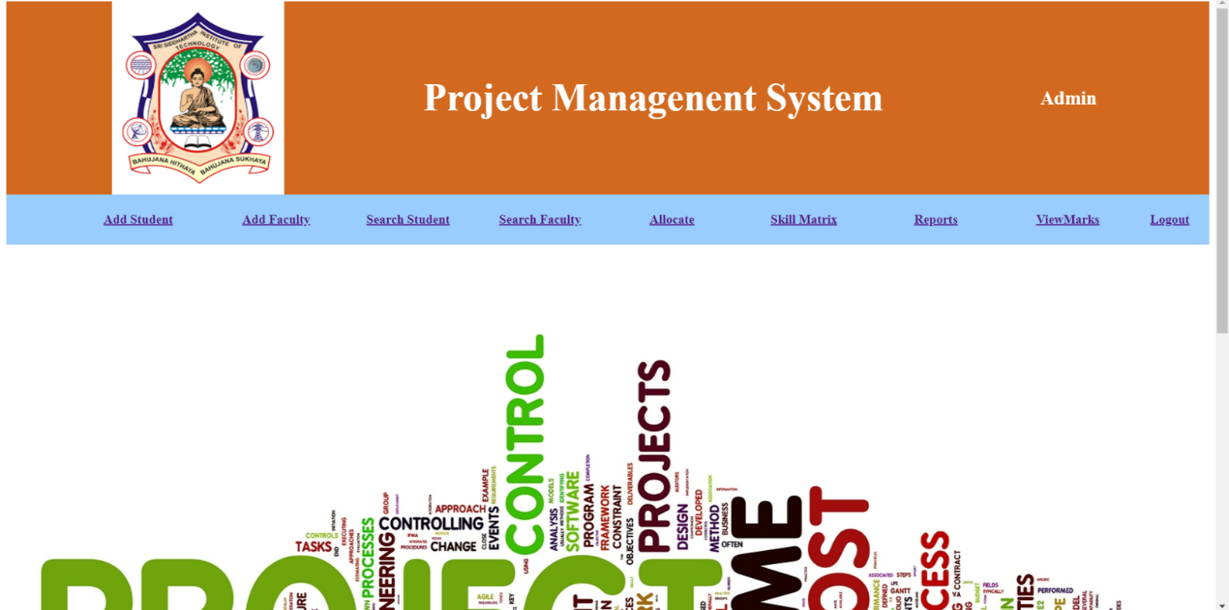 Fig 2: Admin Welcome screen in Admin/HOD panel

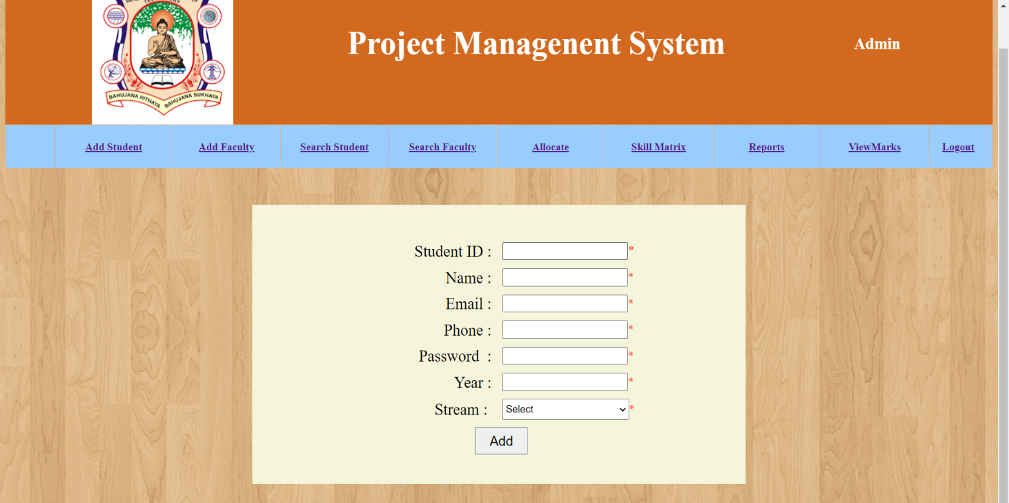Fig 3: Adding student in Admin/HOD panel

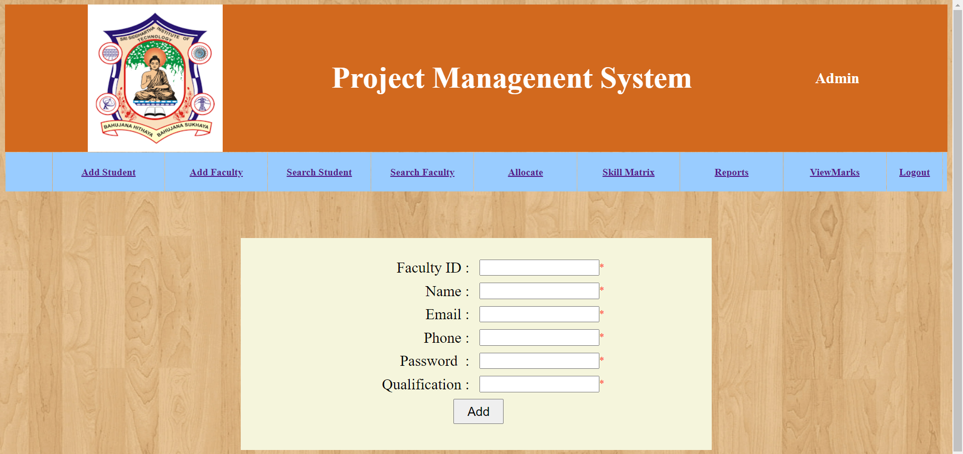

Adding Faculty.

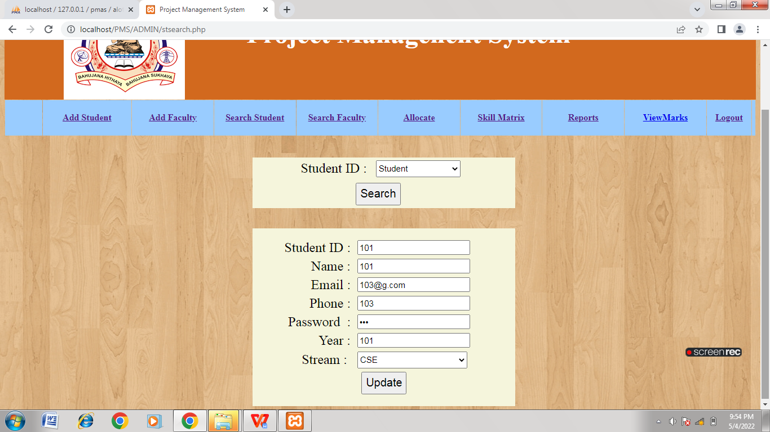

Fig 4: Search student based on student ID in Admin/HOD panel

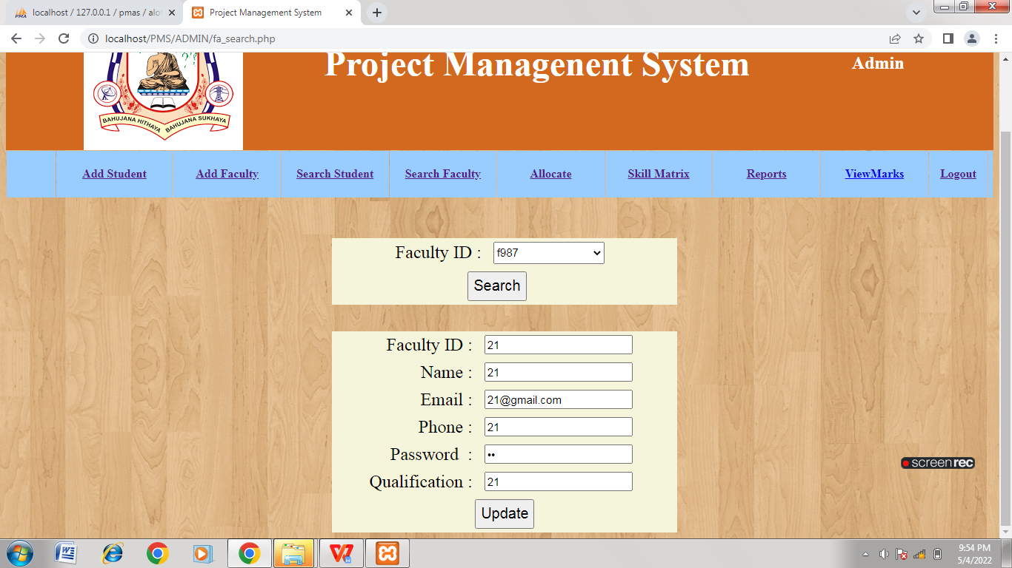

Fig 5: Search faculty based on faculty Id in admin/HOD panel

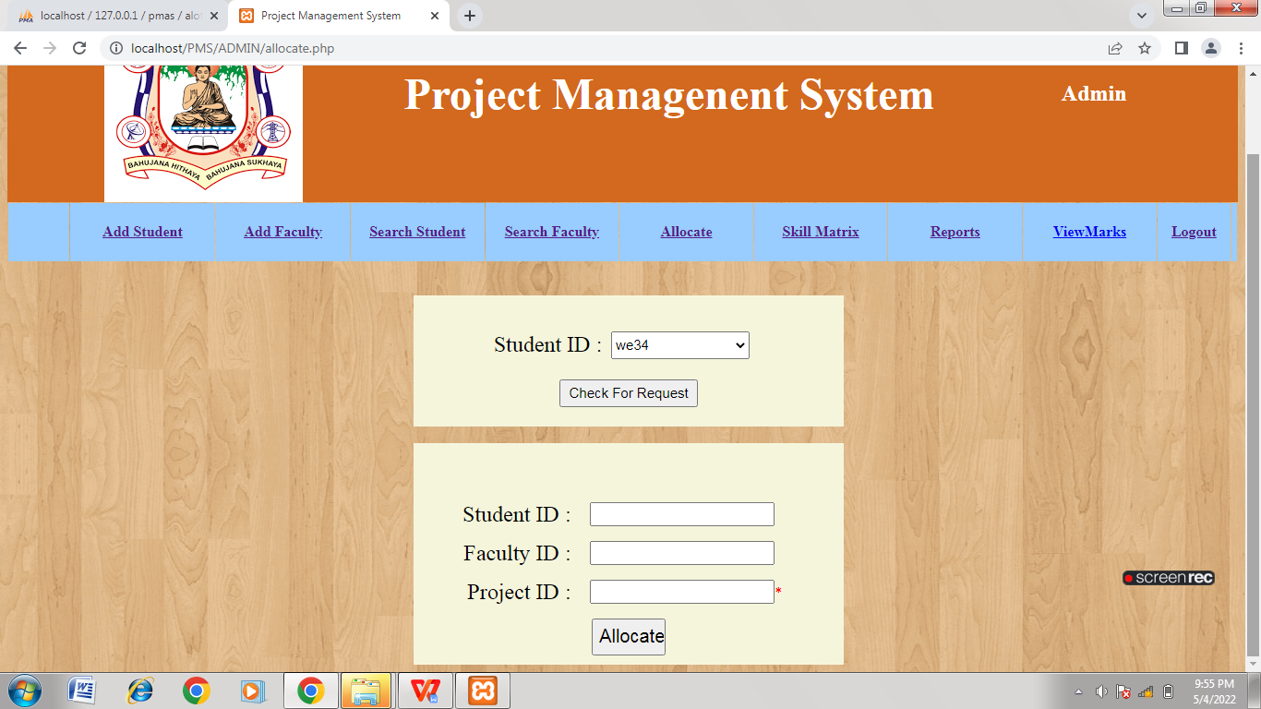

Fig 6: Allocation of project in admin/HOD panel

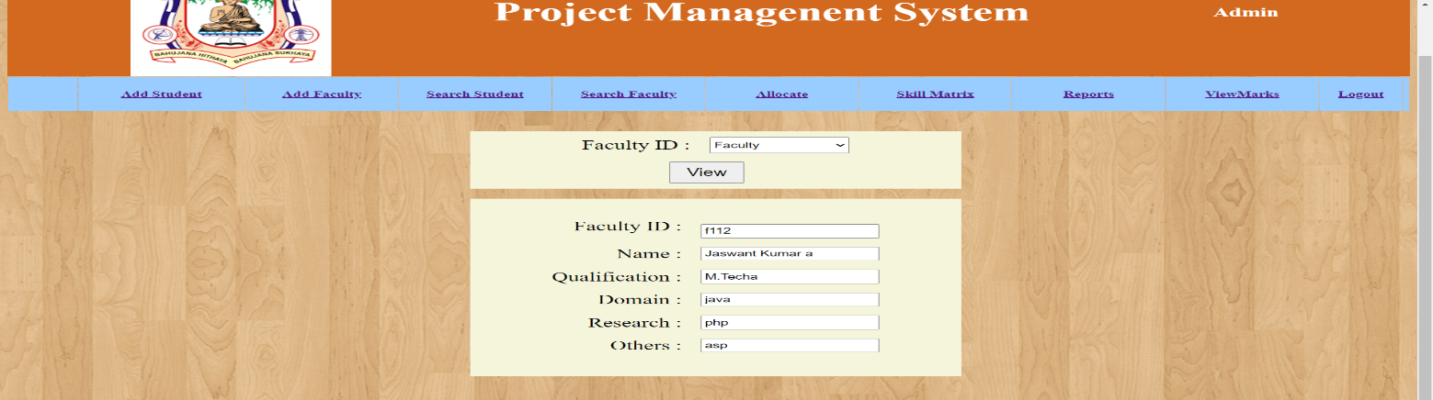

Fig 7: Allocation of faculty.

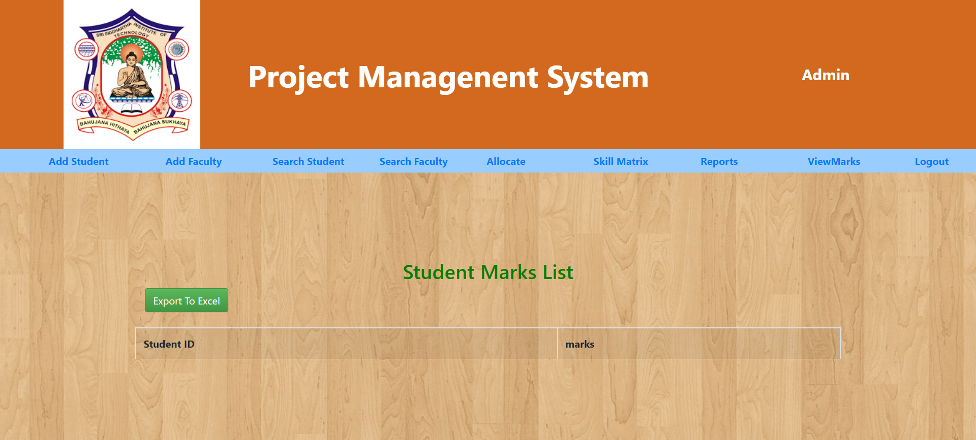

Fig 8: Student marks list

**Faculty module:**

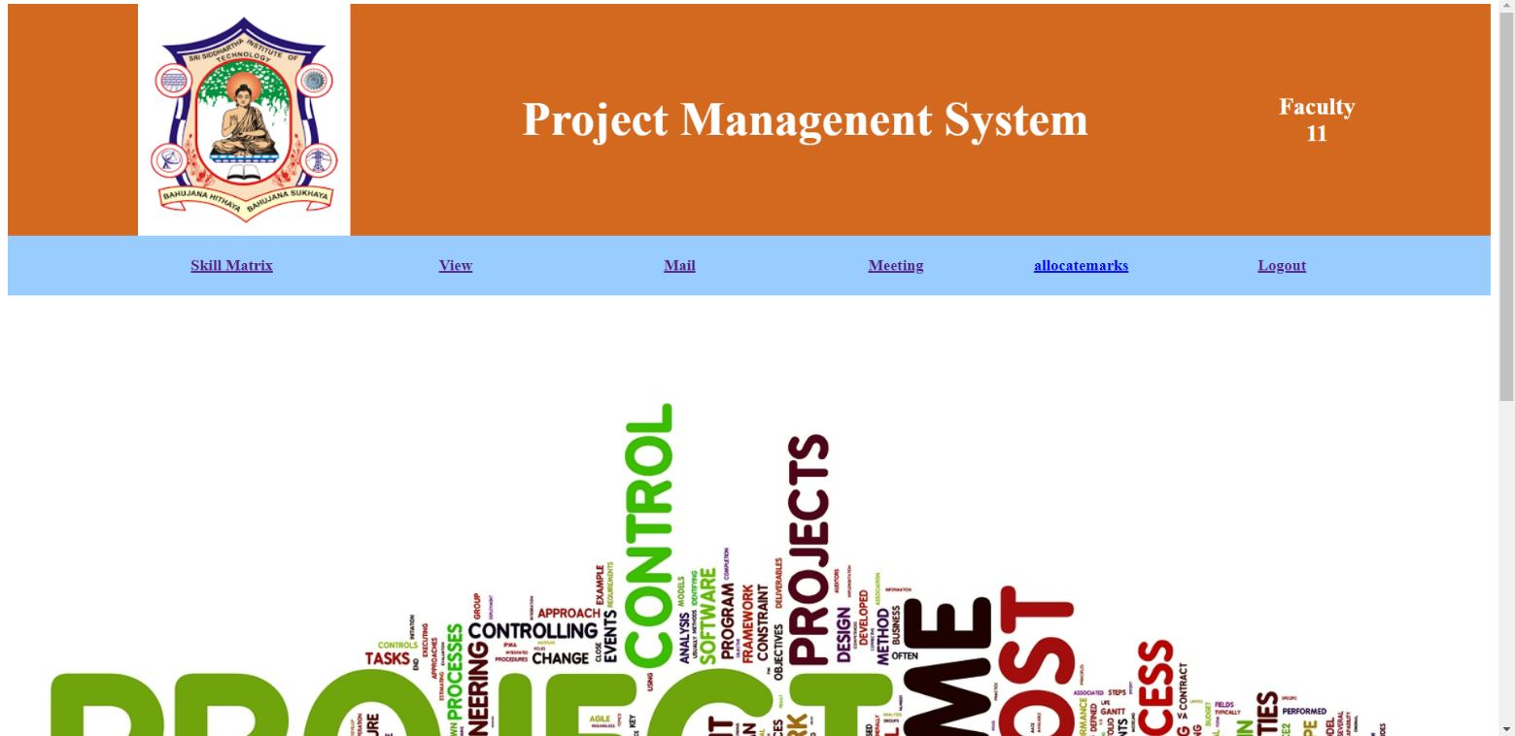

Fig 8: Welcome screen of Faculty

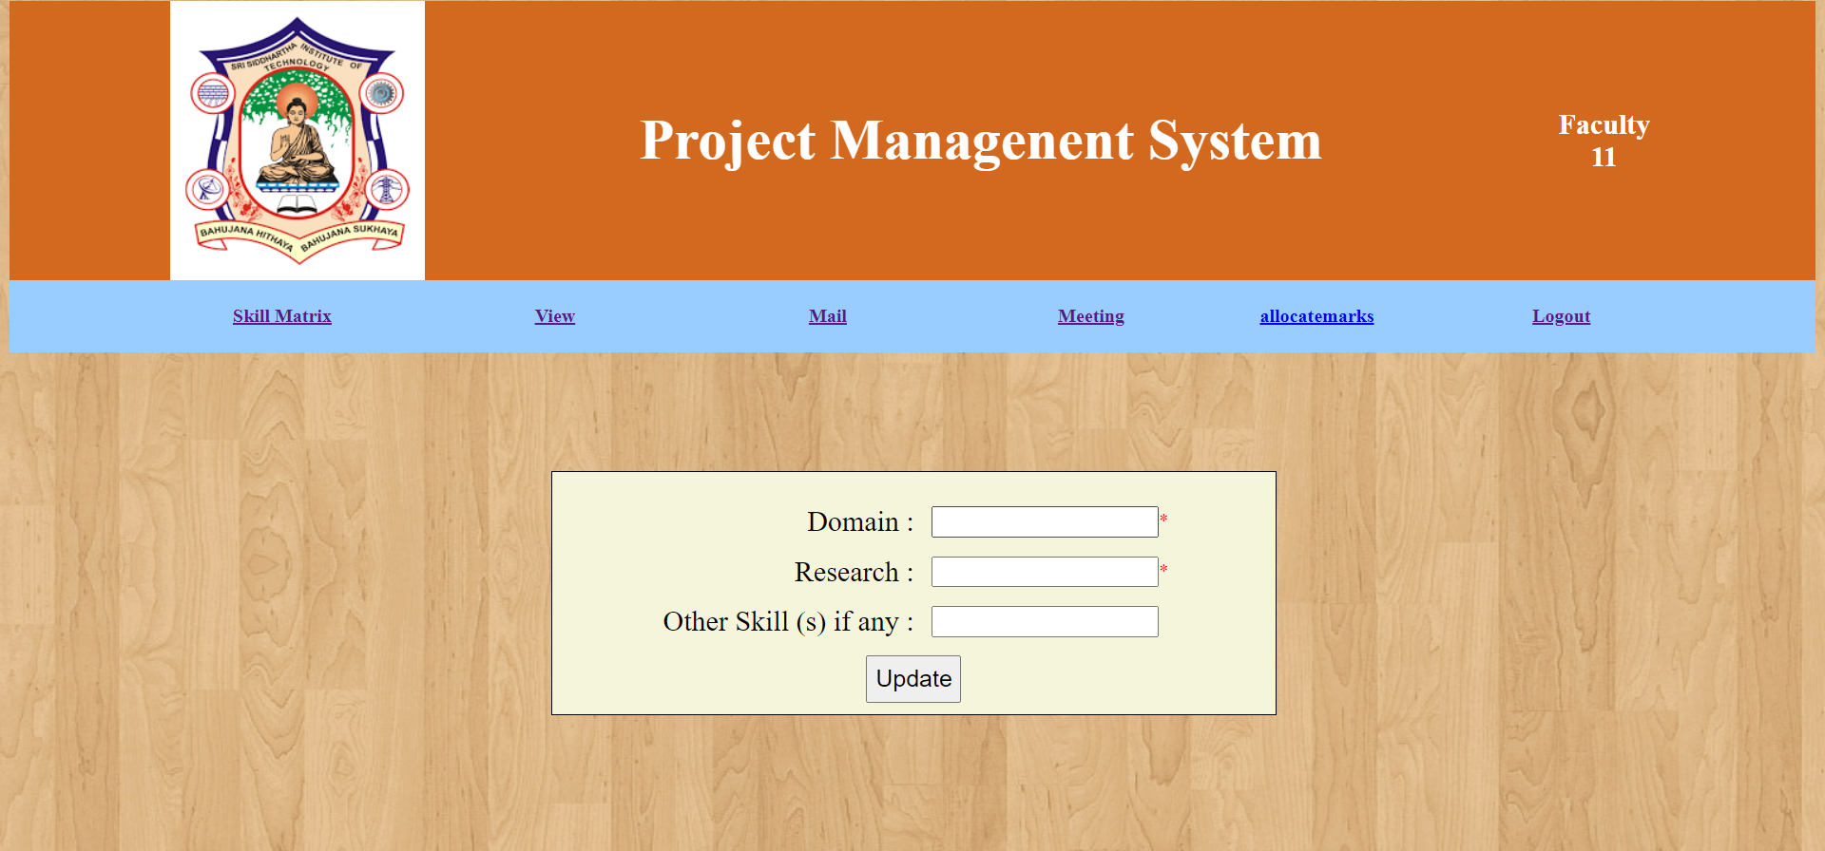

Fig 9: Upgradation of skills of faculty

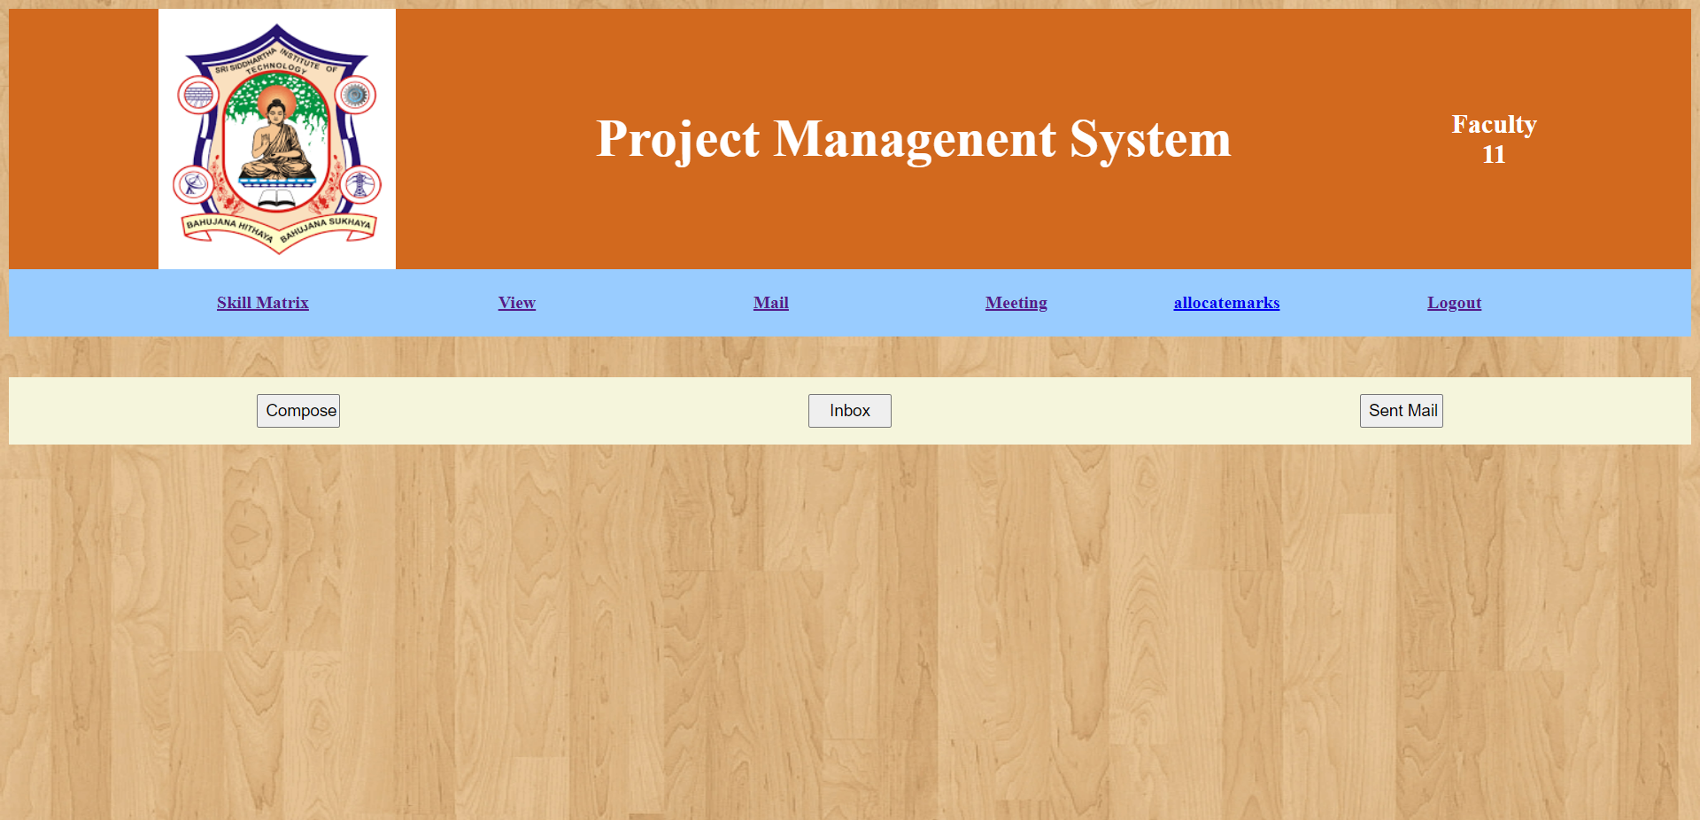

Fig 11: Communication between student and faculty.

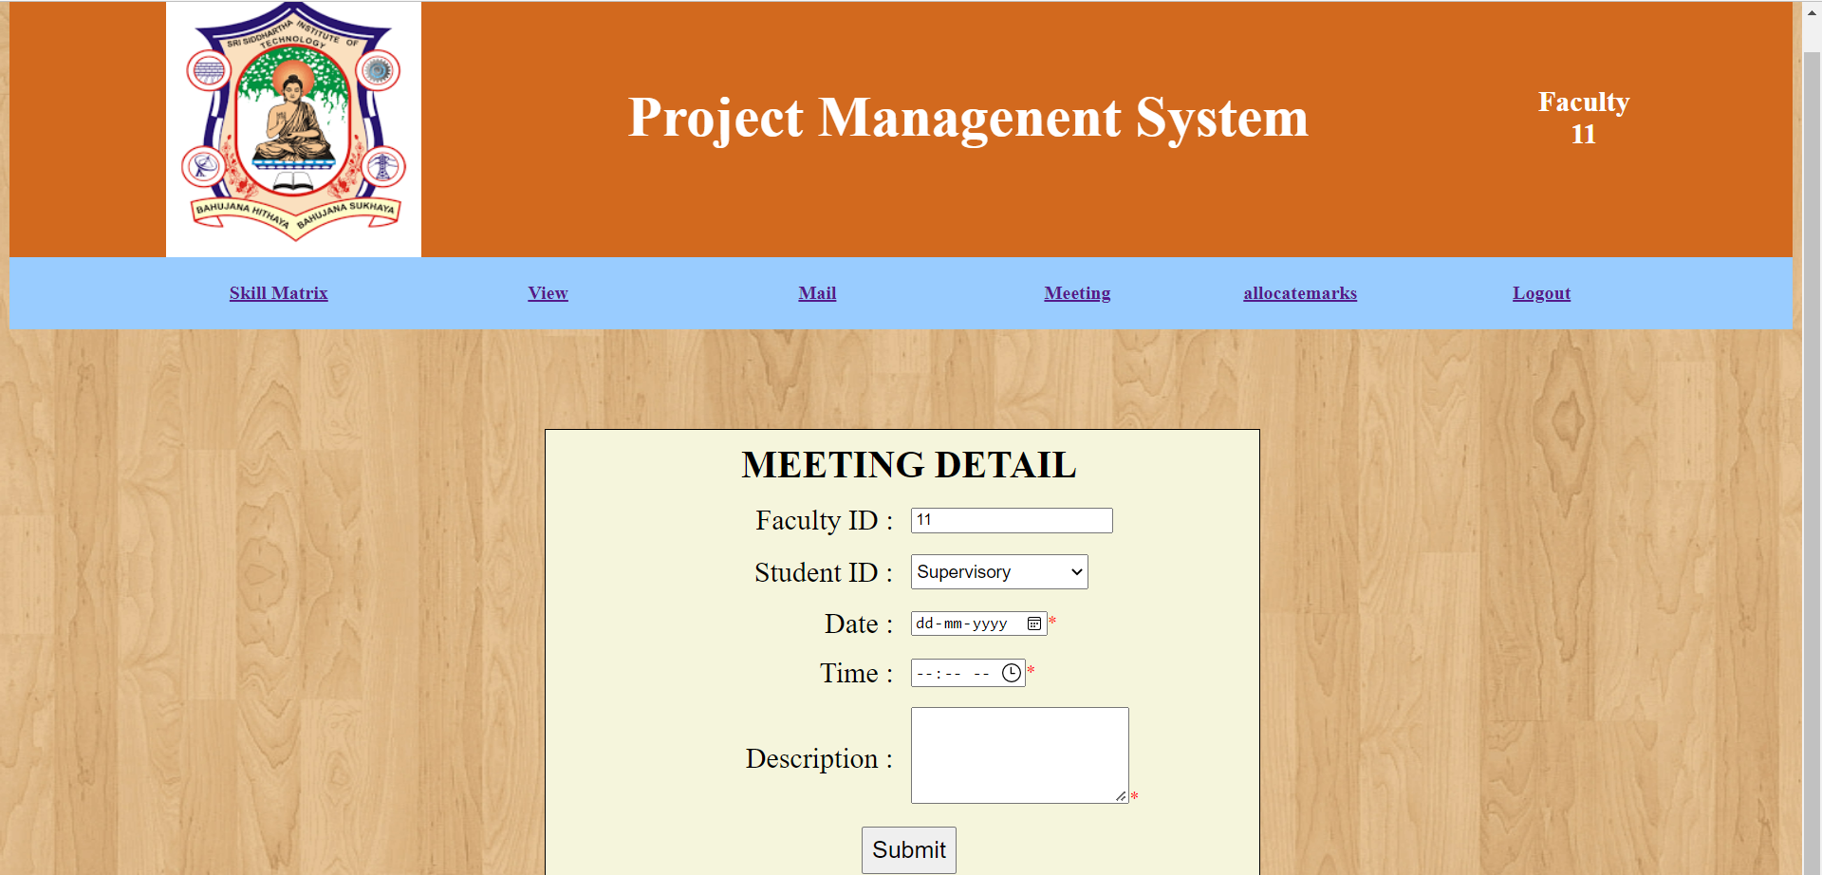

Fig 12: Meeting message for students

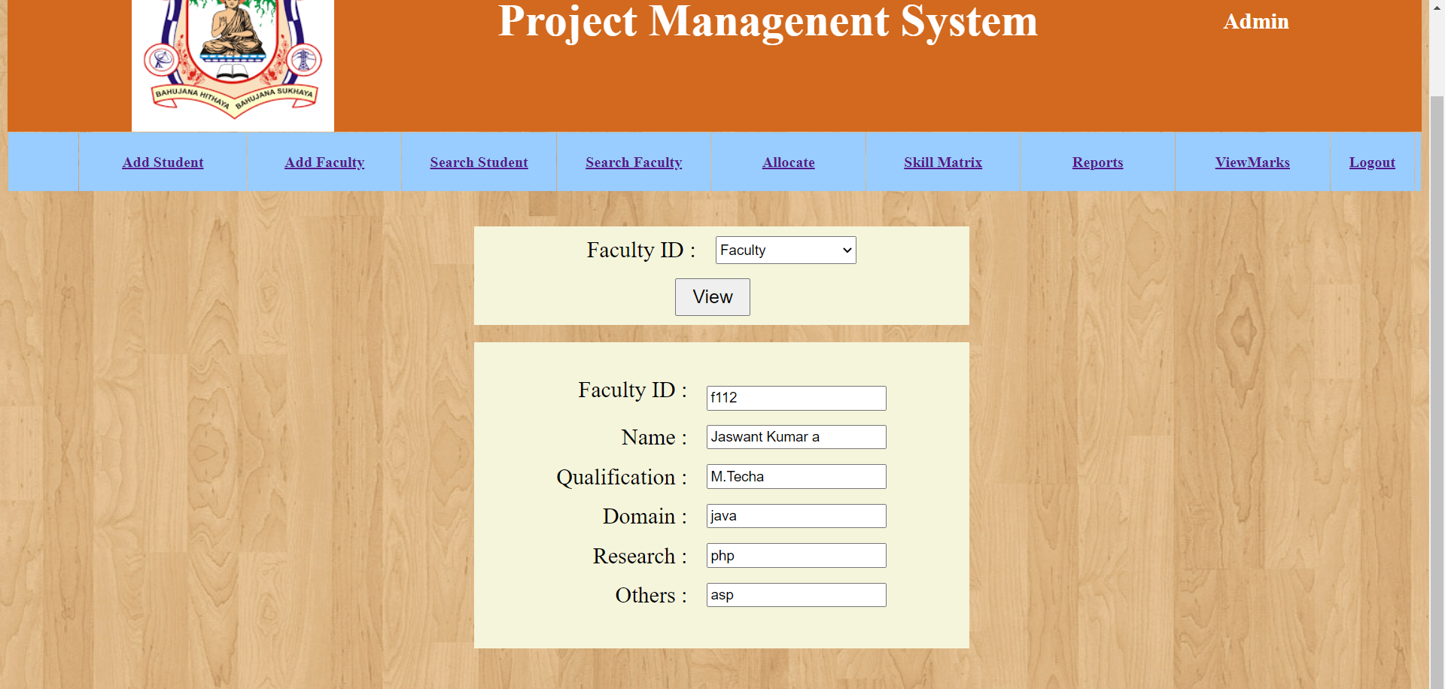

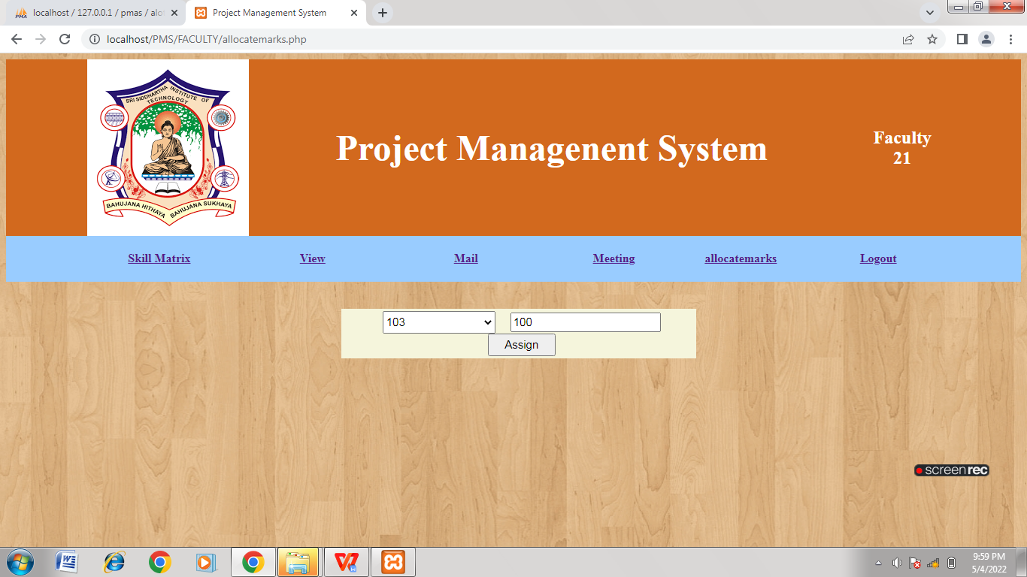

Fig 13: Allocation of marks to students

**STUDENT module:**

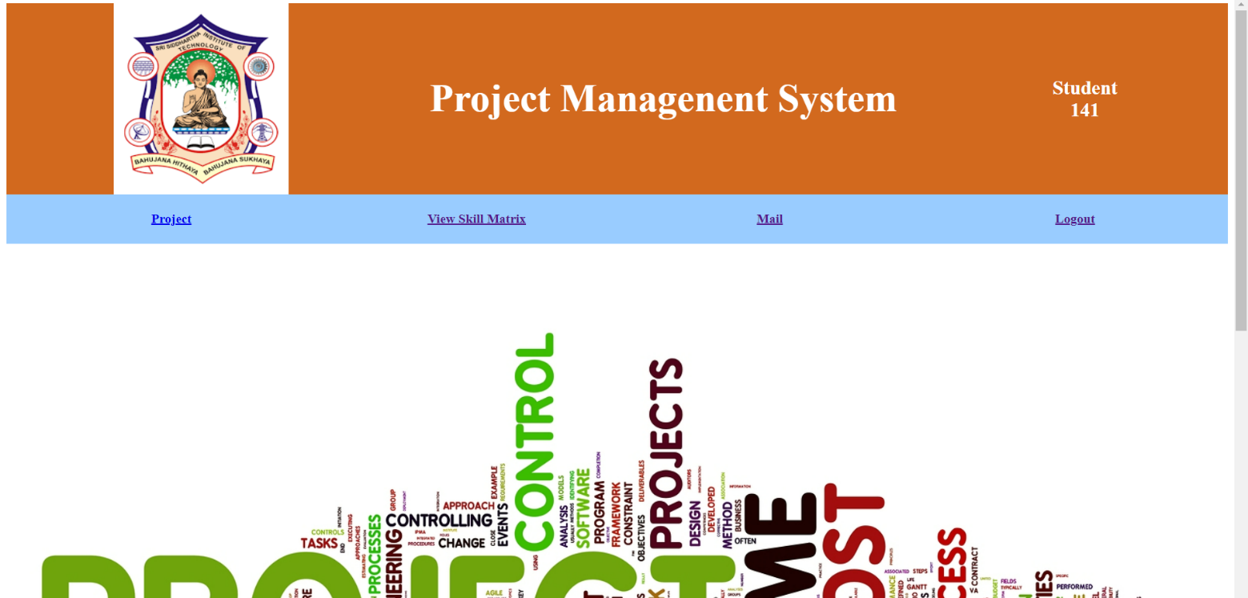

Fig 14: Student Main Screen

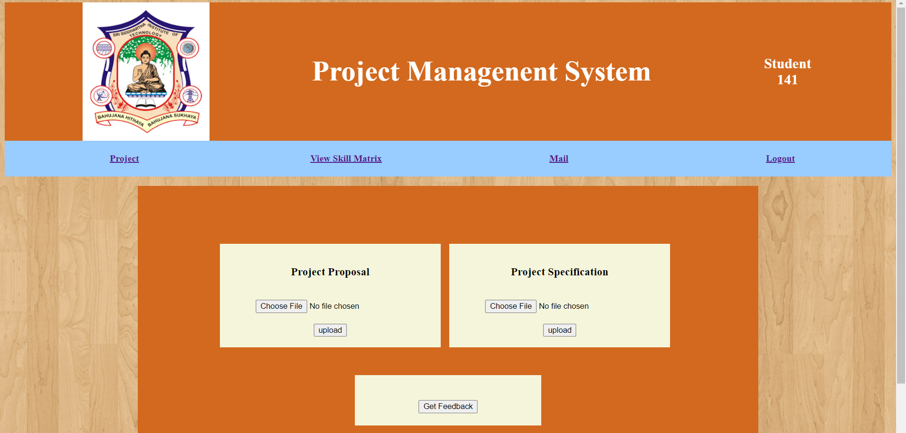

Fig 15: Uploading project report by student.

**STUDENT MODULE**

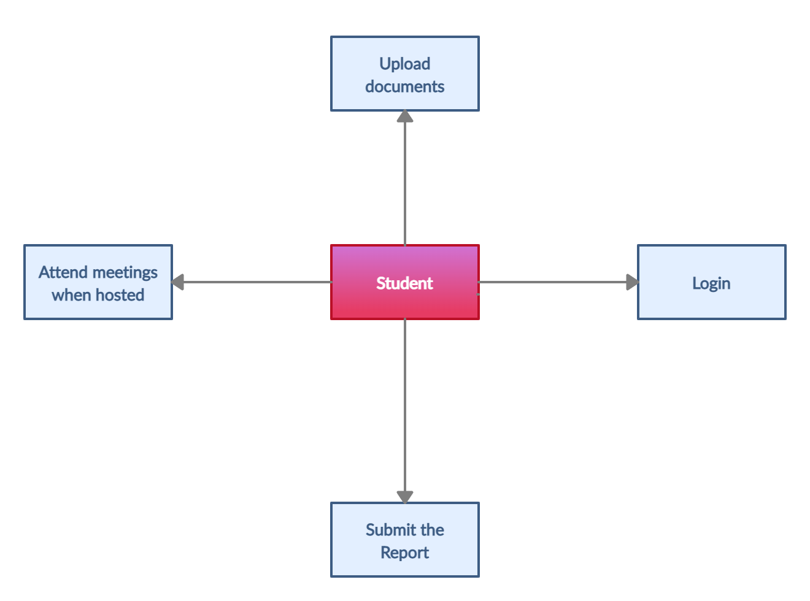

**Student access :-**

* Project
* View skill matrix
* Mail
* Logout

**FACULTY MODULE**

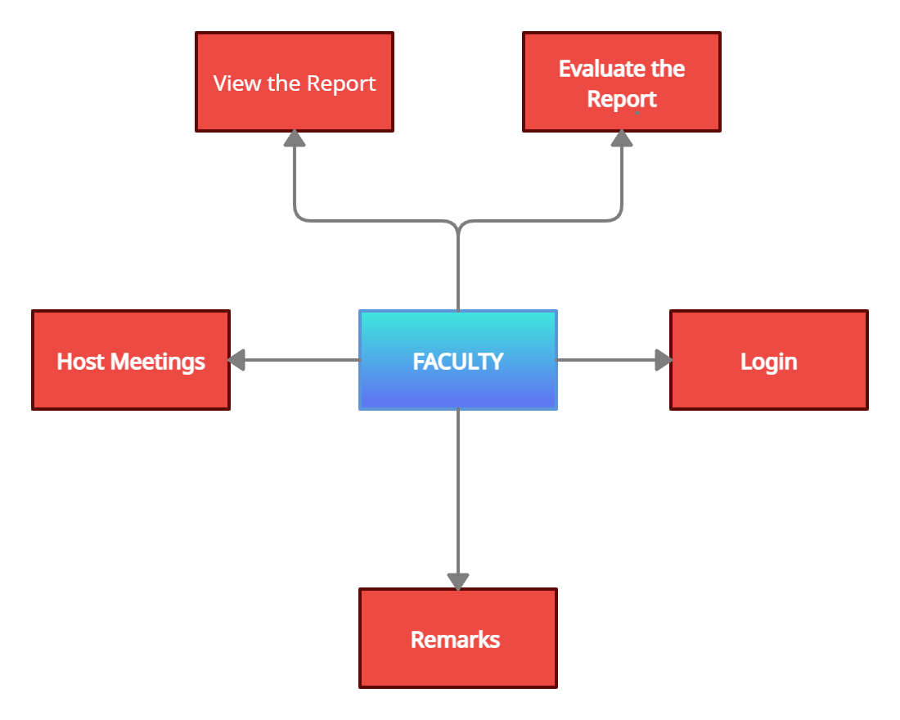

**Faculty access :-**

* Skill matrix
* View
* Mail
* Meeting
* Allocate marks
* logout

**ADMIN MODULE**

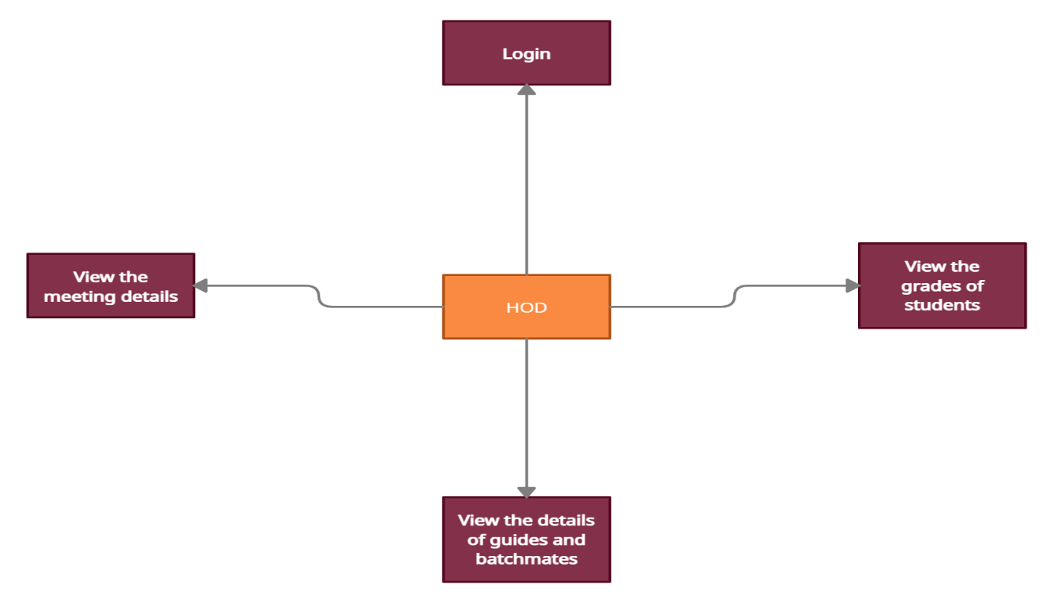

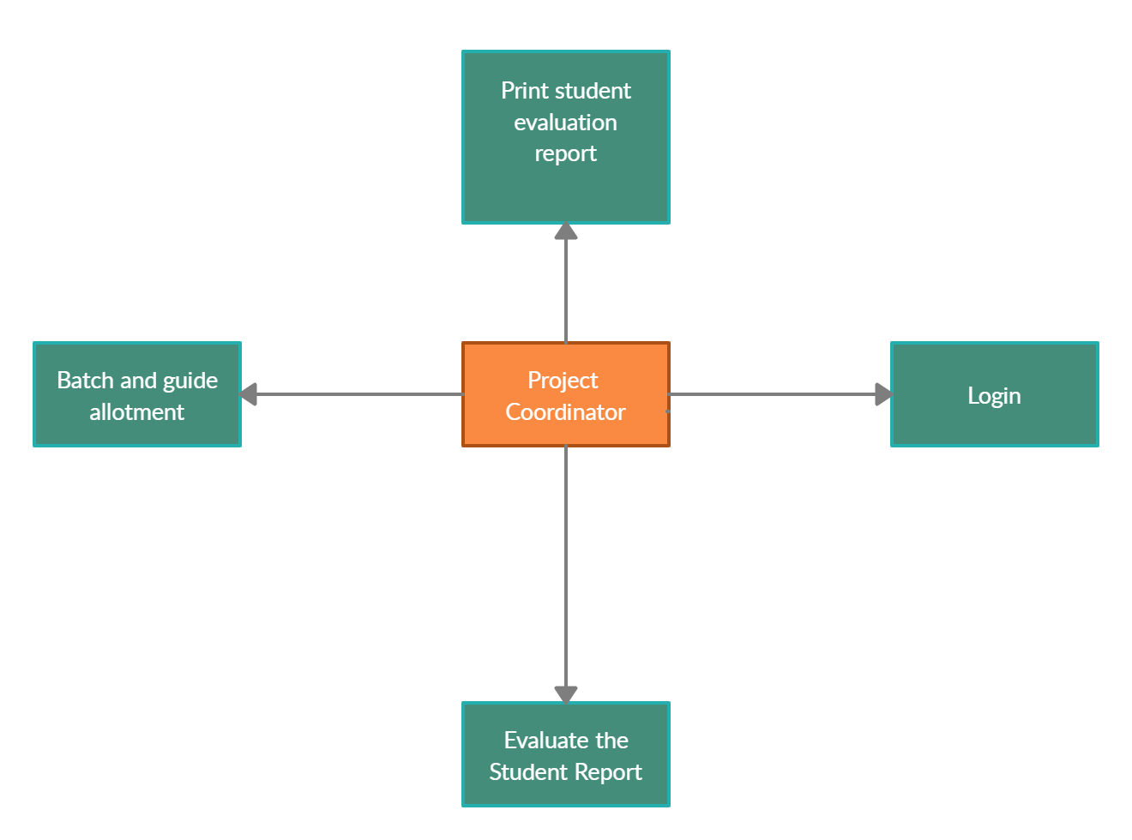

**Admin access:-**

* Add student
* Add faculty
* Search student
* Search faculty
* Allocate
* Skill matrix
* Reports
* View marks
* Logout